STG-455 Weekly Status Update
Production Release Engineering for a Cross-Platform Mobile Application

Project Description
Studio XE is a software platform used by legal, financial, and health care firms to run daily operations, including accounts, documents, messaging, referrals, and tasks. Its mobile application is built with React Native, Expo, and TypeScript and covers 19 screens. The application runs and demonstrates well but is not ready to ship: it has no automated tests, no crash or error reporting, and no release pipeline, and it is not available in either app store. This project builds that missing release infrastructure. Term One produces the release and verification infrastructure and gets the application accepted into Apple TestFlight and Google Play internal testing. Term Two adds offline capability and a shared component definition so the web and mobile applications stay consistent.

Project Status Summary Percent Complete 3.5%
Term One remains in the onboarding and research phase, and overall project completion is 3.5%. NDAs are complete, and the business representative has been contacted to request access to the Studio XE application, source code, development tools, and project materials. Research into the required technologies and review of the known Term One requirements continued while access is pending. Since last week, more research has been done. With the research that was done we are starting to look into different tools that we may want to use when creating the app we want. Since the contact has not gotten back to us we may use something other than React Native. A request was submitted to upgrade to Claude Pro with our budget (as of 10/22 this is still in progress of getting approved by the IT team). The main risk remains a delay in receiving the application and project resources, which would postpone the start of development. Additional risks are listed in the Risks section. Since we have not received the project we are starting research in order to create our own application.

Timeline Snapshot
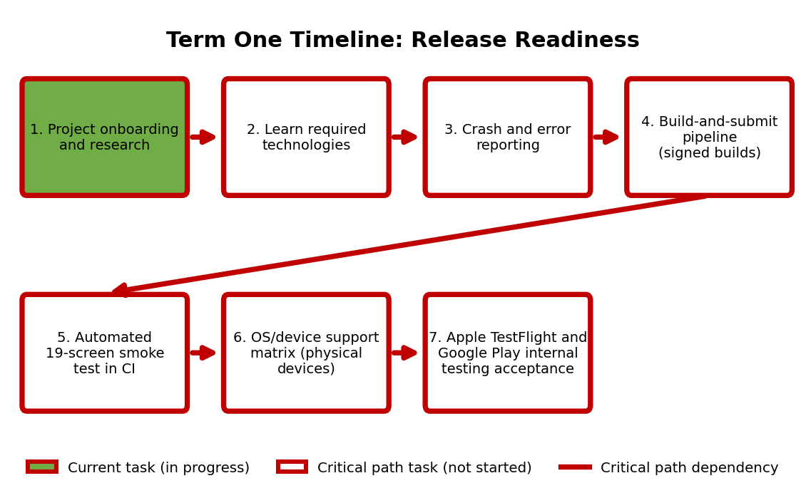

Term One remains in the onboarding and research phase. NDAs are complete, and the business representative has been contacted to request access to the application and project resources. The critical path, marked in red in the diagram, runs from onboarding and research through learning the required technologies, crash and error reporting, the build-and-submit pipeline, the automated 19-screen smoke test in continuous integration, and the OS/device support matrix, ending with internal testing acceptance in Apple TestFlight and Google Play. Onboarding and research remains the current task and will close once access is granted. Technology research can continue in parallel, but crash and error reporting and every later critical path task depend on access to the source code. Because store review timing is controlled by Apple and Google, a minimal build will be submitted to both stores within the first six weeks so that review delays are discovered early.

Current Concept
The Studio XE application has not yet been provided, so a screenshot of the current prototype is not available. The planned Term One concept shown below is unchanged from the previous week: source code passes through a continuous integration smoke test of all 19 screens, EAS Build produces signed iOS and Android builds, and EAS Submit sends them to Apple TestFlight and Google Play internal testing. Crash and error reporting covers all build configurations, and the OS/device support matrix is validated on physical devices. Once the application is available, the current prototype will be captured and used as the baseline for all future changes.
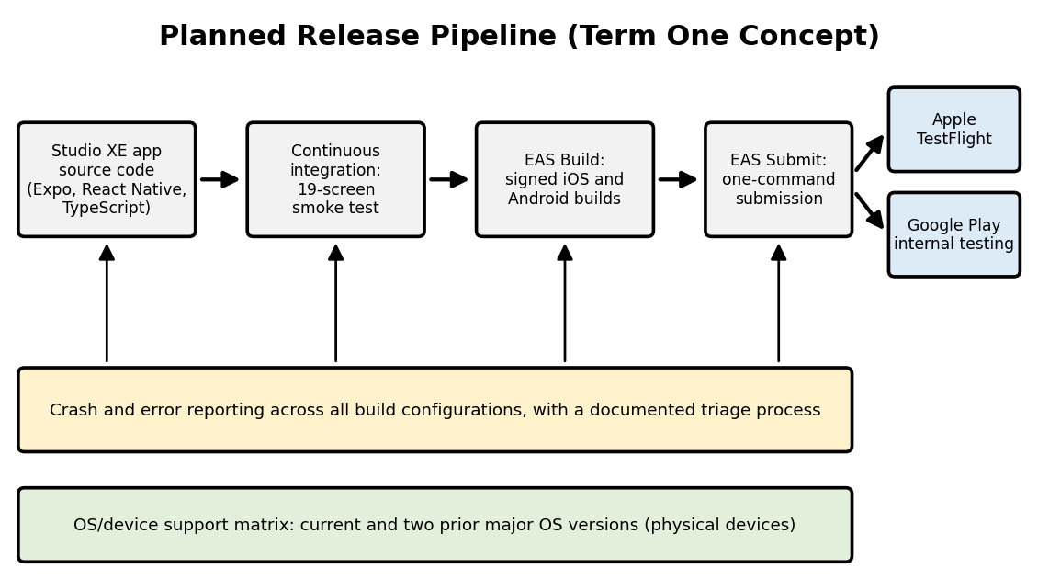

Accomplishments and Learning
Planned from last week
- Critical Path: Contact the business representative to gain access to project information, development tools, existing project materials, and the Studio XE application. Also starting research for our own app to start the development process.
  - Complete. The business representative was contacted with a request for access to the application, source code, development tools, and project materials. A response and access are pending.
  - Since the contact has not gotten back to us we are going to start creating our own application, research has started because we do not necessarily want to use React native so we are looking for a different/easier tool to use.
- Examine the current application architecture and project requirements once access is gained.
  - Not started. This task depends on access to the application and source code, which has not yet been granted.
- Determine the technologies, tools, and development approaches that must be mastered before development begins.
  - In progress. Research into Expo, React Native, EAS Build and Submit, continuous integration, and crash reporting tools continued. The final list depends on a review of the existing codebase.
- Determine the requirements for Term One release readiness, including OS/device testing, the build-and-submit process, automated smoke testing, and crash and error reporting.
  - In progress. The known Term One requirements have been identified from the project description. Confirmation with the business representative is pending.
Unplanned
- No significant unplanned tasks or findings at this time.
Findings / Lessons Learned
- Access to the application and source code is the gating dependency for every critical path task after onboarding, so follow-up with the business representative is the top priority.
- Technology research can proceed in parallel with the access request, which will reduce the learning time required once access is granted.

Work Planned for Next Week
- Critical Path: Follow up with the business representative to obtain access to the Studio XE application, source code, development tools, and project materials. If the contact does not respond we will start by creating a GitHub repository and starting work on our app.
- Once access is granted, examine the current application architecture, build configuration, and project requirements.
- Finalize the list of technologies, tools, and development approaches required for Term One.
- Confirm the Term One release-readiness requirements with the business representative, including OS/device testing, the build-and-submit process, automated smoke testing, and crash and error reporting.
Milestone: Obtain access to the Studio XE application and all project resources required to start development.

Risks
- Access to the Studio XE application and project resources has been requested but not yet granted (Still true through 10/22). A continued delay would prevent development from starting and push back every critical path task. Mitigation: follow up with the business representative regularly and escalate to the project mentor if access is not granted within the next week.
- Limited experience with the project tools and technologies (Expo, React Native, EAS, continuous integration, and mobile testing) could require extra learning time before implementation. Mitigation: continue research while access is pending and prioritize the technologies needed for the critical path.
- Incomplete or unclear project requirements could cause ambiguity about the required product. Mitigation: document assumptions and confirm them with the business representative.
- Integration problems with cross-platform device testing, crash reporting, automated testing, or the release pipeline could require extra development time. Mitigation: build and test each piece incrementally, starting with a minimal build.
- App store review timing is controlled by Apple and Google and could delay TestFlight and Google Play acceptance. Mitigation: submit a minimal build to both stores within the first six weeks so that review latency is discovered early.

Deliverables and Milestones

Milestone | Planned | Forecasted | Actual | Status
Complete project onboarding and NDAs | 10/02/2026 | 10/02/2026 | 10/02/2026 | Completed
Obtain Studio XE application and project resources | TBD | TBD | — | In Progress
Complete requirements and technology review | TBD | TBD | — | Pending
Establish development plan | TBD | TBD | — | Pending
Deliverable | Planned | Forecasted | Actual | Status
Crash and error reporting across all build configurations, with a documented triage process | TBD | TBD | — | Not Started
Build-and-submit pipeline producing signed iOS and Android builds from a single command | TBD | TBD | — | Not Started
Automated 19-screen smoke test running in continuous integration | TBD | TBD | — | Not Started
OS/device support matrix covering the current and two prior major OS versions, validated on physical devices | TBD | TBD | — | Not Started
Apple TestFlight acceptance | TBD | TBD | — | Not Started
Google Play internal testing acceptance | TBD | TBD | — | Not Started

Attachments
N/A

Approvals:

Team Role | Print Name | Signature | Date
Team Lead | Gabriel Veltri |  | 10/22/2026
Team Member | Fernando Hernandez Leon |  | 10/22/2026
Team Member | Austin Kelemen |  | 10/22/2026
Team Member | Luke Hoyle |  | 10/22/2026
Mentor | Shad Sluiter |  | 10/22/2026

